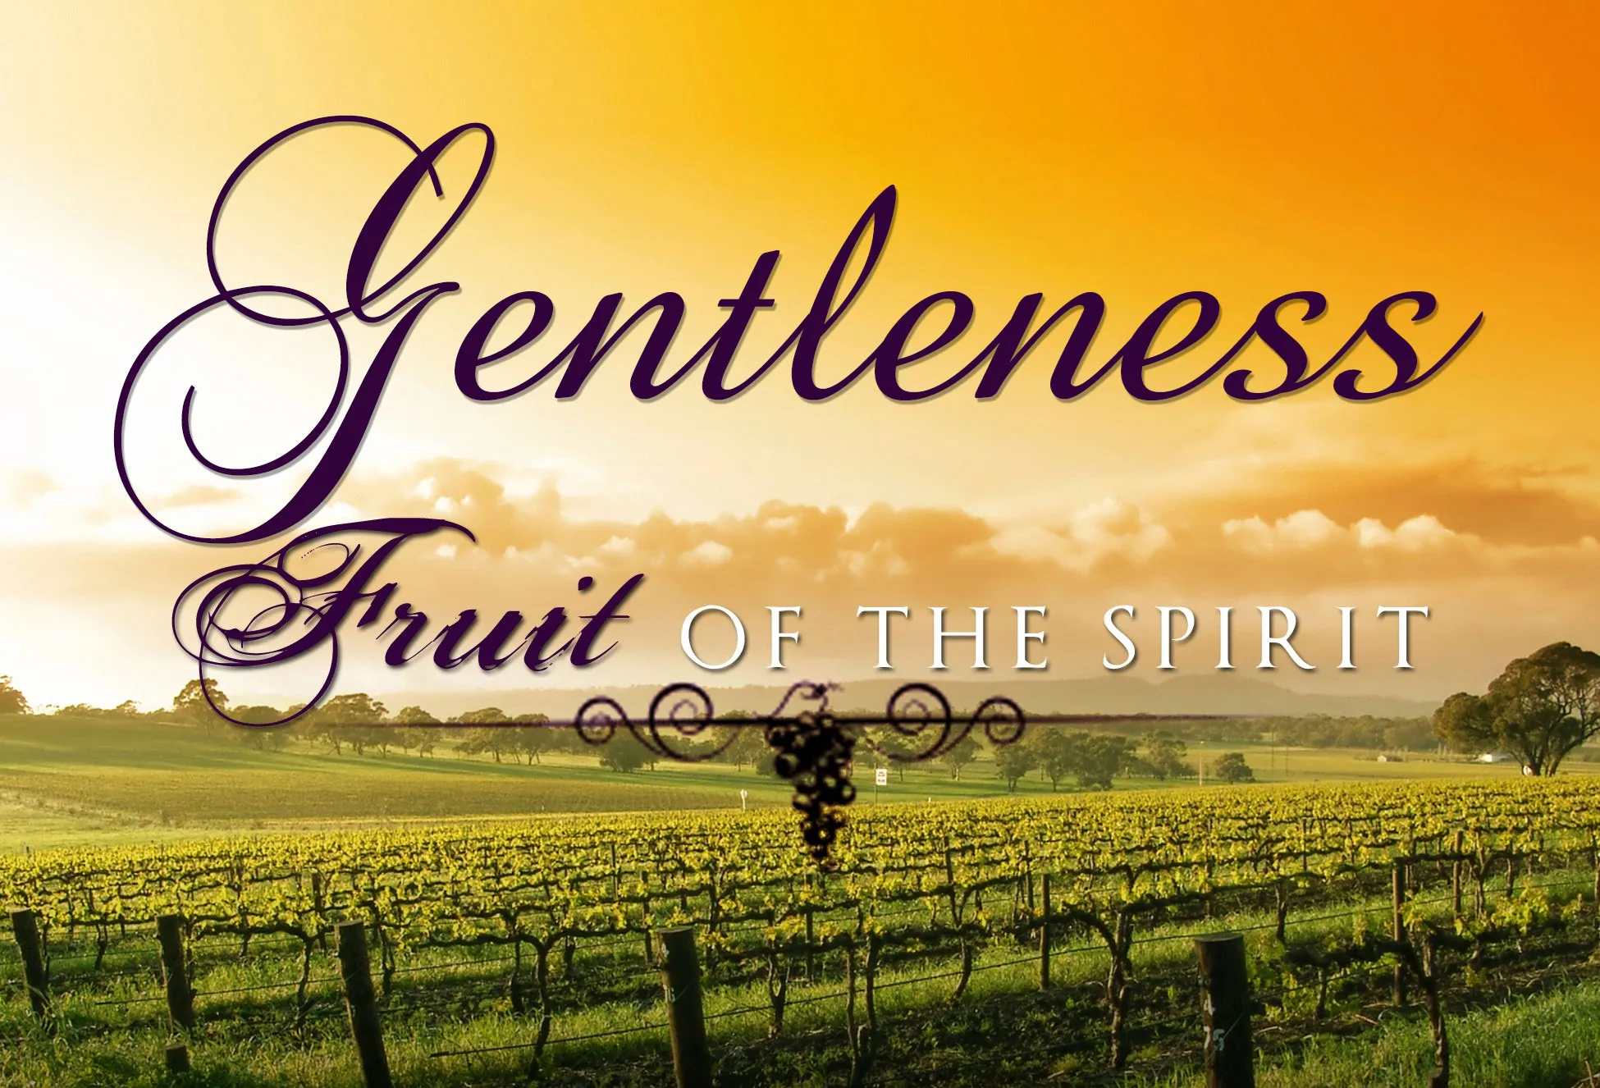

The Fruit of the Spirit is…Gentleness
Tenth Sunday after Pentecost
August 14, 2022
10:00 a.m.

Our Savior’s Lutheran Church
8607 S. Narragansett Ave.
Burbank, Illinois
708-599-4780
www.oursaviorschurch.org

Welcome to worship at Our Savior’s Lutheran Church. Thank you for worshiping with us. Please wear a nametag and introduce yourself to those sitting near you. We would enjoy getting to know you better and pray that our ministry may help you in your relationship with God and your Spiritual growth.
For those worshiping from home:
Pre-service Music-Bring this service folder and a candle, to your place of worship.

We will be sharing Communion today! Please bring bread and wine or juice so that we may all share in God’s gift together. You may also call the church office to have pre-consecrated communion elements delivered to you to use in worship.

Prelude

Gathering________________________________

WELCOME AND ANNOUNCEMENTS

The Peace of Christ be with you
And also with you.

Please take a moment to share a wave, a nod or a sign of peace with those around you. The congregation remains standing.

Confession and Forgiveness
All may make the sign of the cross, the sign that is marked at baptism, as the presiding minister begins.

Blessed be the holy Trinity, +one God, whose steadfast love endures forever. Amen

Let us confess our sin in the presence of God and of one another.

Silence is kept for reflection.

Merciful God,
We confess that we have not followed your path but have chosen our own way. Instead of putting others before ourselves, we long to take the best seats at the table. When met by those in need, we have too often passed by on the other side. Set us again on the path of life. Save us from ourselves and free us to love our neighbors. Amen.

Hear the good news! God does not deal with us according to our sins but delights in granting pardon and mercy. In the name of +Jesus Christ, your sins are forgiven. You are free to love as God loves. Amen.

♫Gathering Hymn The Trumpets Sound, the Angels Sing

The trumpets sound, the angels sing, the feast is ready to begin.
The gates of heav’n are open wide,
and Jesus welcomes you inside.
Sing with thankfulness songs of pure delight.
Come and revel in heaven’s love and light.
Take your place at the table of the King.
The feast is ready to begin;
The feast is ready to begin.

The hungry heart he satisfies, offers the poor his paradise.
Now hear all heav’n and earth applaud
the amazing goodness of the Lord.
Sing with thankfulness songs of pure delight.
Come and revel in heaven’s love and light.
Take your place at the table of the King.
The feast is ready to begin;
The feast is ready to begin.

The grace of our Lord Jesus Christ, the Love of God and the communion of the Holy Spirit be with you all.
c And also with you.

PRAYER OF THE DAY
O God, judge eternal, you love justice and hate oppression, and you call us to share your zeal for truth. Give us courage to take our stand with all victims of bloodshed and greed, and, following your servants and prophets, to look to the pioneer and perfecter of our faith, your Son, Jesus Christ, our Savior and Lord. c Amen
The congregation is seated

Word____________________________
A Reading from Jeremiah
Jeremiah 23:23-29

Because Jeremiah preaches the unpopular message of God’s judgment, he suffers rejection. Today’s reading distinguishes between the true prophet, like Jeremiah, who speaks God’s word, and the false prophet who misleads the people through dreams. One is like wheat; the other like worthless straw.

²³Am I a God near by, says the Lord, and not a God far off? ²⁴Who can hide in secret places so that I cannot see them? says the Lord. Do I not fill heaven and earth? says the Lord. ²⁵I have heard what the prophets have said who prophesy lies in my name, saying, “I have dreamed, I have dreamed!” ²⁶How long? Will the hearts of the prophets ever turn back—those who prophesy lies, and who prophesy the deceit of their own heart? ²⁷They plan to make my people forget my name by their dreams that they tell one another, just as their ancestors forgot my name for Baal. ²⁸Let the prophet who has a dream tell the dream, but let the one who has my word speak my word faithfully. What has straw in common with wheat? says the Lord. ²⁹Is not my word like fire, says the Lord, and like a hammer that breaks a rock in pieces?

Word of God, word of life.
Thanks be to God.

GOSPEL ACCLAMATION Christ, Be Our Light

♫ Christ, be our light! Shine in our hearts.
Shine through the darkness.
Christ, be our light!
Shine in your church gathered today.

The Holy Gospel According to Luke the 12th Chapter
Luke 12:49-56

Glory to you, O Lord

Jesus delivers harsh words about the purifying and potentially divisive effects of obedience to God’s call. The way of the cross often leads followers to encounter hostility and rejection, even from those they love.

[Jesus said:] ⁴⁹“I came to bring fire to the earth, and how I wish it were already kindled! ⁵⁰I have a baptism with which to be baptized, and what stress I am under until it is completed! ⁵¹Do you think that I have come to bring peace to the earth? No, I tell you, but rather division! ⁵²From now on five in one household will be divided, three against two and two against three; ⁵³they will be divided:
father against son
and son against father,
mother against daughter
and daughter against mother,
mother-in-law against her daughter-in-law
and daughter-in-law against mother-in-law.”
⁵⁴He also said to the crowds, “When you see a cloud rising in the west, you immediately say, ‘It is going to rain’; and so it happens. ⁵⁵And when you see the south wind blowing, you say, ‘There will be scorching heat’; and it happens. ⁵⁶You hypocrites! You know how to interpret the appearance of earth and sky, but why do you not know how to interpret the present time?”

The Gospel of the Lord
c Praise to you, O Christ

♫ Christ, be our light! Shine in our hearts.
Shine through the darkness.
Christ, be our light!
Shine in your church gathered today.
☺Children’s Message

The Message for the Day

♫Hymn of the Day Spirit of Gentleness

(refrain)
Spirit, Spirit of gentleness,
blow through the wilderness calling and free;
Spirit, Spirit of restlessness,
Stir me from placidness, wind, wind on the sea.

You moved on the waters, you called to the deep,
Then you coaxed up the mountains from the valleys of sleep;
And over the eons you called to each thing:
“Awake from your slumbers and rise on your wings.” Refrain

You sang in a stable, you cried from a hill,
then you whispered in silence when the whole world was still;
And down in the city you called once again,
when you blew through your people
on the rush of the wind. Refrain

You call from tomorrow, you break ancient schemes.
From the bondage of sorrow all the captives dream dreams;
Our women see visions, our men clear their eyes.
With bold new decisions your people arise. Refrain

APOSTLES’ CREED
Let us stand and confess our faith together.
I believe in God, the Father almighty,
creator of heaven and earth.
I believe in Jesus Christ, God’s only Son, our Lord,
who was conceived by the Holy Spirit, born of the virgin Mary, suffered under Pontius Pilate, was crucified, died, and was buried; he descended to the dead.

On the third day he rose again; he ascended into heaven,
he is seated at the right hand of the Father,
and he will come to judge the living and the dead.
I believe in the Holy Spirit, the holy catholic church,
the communion of saints, the forgiveness of sins,
the resurrection of the body, and the life everlasting.Amen

Prayers of the church

Trusting in God’s extraordinary love, let us come near to the Holy One in prayer.

The congregation is seated

Arise, O God, and sustain your church. We pray for all who dedicate their lives to serving your people. Renew our commitment to our siblings in faith around the globe, and bless the work of our ecumenical and interfaith partners. Merciful God,
receive our prayer.
Arise, O God, and sustain your creation. We pray for all places affected by natural disasters Transform the devastation of floods and fires into fertile ground for new life and growth. Fill heaven and earth with your life-giving Spirit. Merciful God,
receive our prayer.
Arise, O God, and sustain the nations. We pray for all elected officials. Kindle in them a desire to administer your justice with gentle strength. Strengthen their resolve to defend those who are vulnerable and to stand publicly against all forms of oppression. Merciful God,
receive our prayer.
Arise, O God, and sustain those who are oppressed. We pray for people harmed by racist discrimination, ableist discrimination, and all people discriminated against based on their gender identity or sexual orientation. Raise up in us the will to be gentle with one another. Rescue us from all systems that degrade our fellow human beings. Merciful God,
receive our prayer.

Surrounded by so great a cloud of witnesses, we remember the saints who have gone before us. May we run with perseverance the race set before us until we find our rest in you. Merciful God,
receive our prayer.
Receive the prayers of your children, merciful God, and hold us forever in your steadfast love; through Jesus Christ, our holy Wisdom.
Amen.

INVITATION TO GENEROSITY

Musical Offering Firm Foundation
Adult Choir

(The assembly stands when the collection is brought forward)
PRAYER

Let us pray together: God of abundance: you have set before us a plentiful harvest. As we feast on your goodness, strengthen us to labor in your field, and equip us to bear fruit for the good of all, in the name of Jesus. Amen.

Meal
The Lord be with you.
c And also with you.


Lift up your hearts.
c We lift them to the Lord.

Let us give thanks to the Lord our God.
c It is right to give our thanks and praise.

PREFACE

♫ Holy is Our God

♫ Holy is our God whose name we praise forever!
Glory to the Son who reigns in majesty!
Come, Spirit, come and fill our hearts with wisdom;
That we may long to worship you alone.

EUCHARISTIC PRAYER

LORD'S PRAYER
Lord, remember us in your kingdom and hear us as we pray:

Our Father, who art in heaven, hallowed be thy name,
thy kingdom come, thy will be done, on earth as it is in heaven.
Give us this day our daily bread;
and forgive us our trespasses, as we forgive those who trespass against us; and lead us not into temptation but deliver us from evil. For thine is the kingdom, and the power, and the glory, forever and ever. Amen

INVITATION TO COMMUNION

Lamb of God, you take away the sin of the world;
c have mercy on us.
Lamb of God, you take away the sin of the world;
c have mercy on us.
Lamb of God, you take away the sin of the world;
c grant us peace.

In Christ’s presence there is fullness of joy. Join him in the banquet.
please be seated

We invite all who trust in Jesus to share in Holy Communion.
To receive communion come down the center aisle and fill in around the communion table as room opens up. When taking the cup of wine please be careful to only touch one cup. After receiving communion return via the outside aisle leaving your used cup in the baskets by the first row of pews. Those who are unsure about our traditional way of receiving communion may pick up prefilled packs at the front of the church and bring them to your place around the table for you to eat and drink the holy elements.

✵ The Welcome Table

We’re gonna sit at the Welcome Table!
We’re gonna sit at the Welcome Table
one o’these days; Alleluia!
We’re gonna sit at the Welcome Table!
Gonna sit at the Welcome Table one of these days!

Jesus calls us to that table!
Jesus calls us to that table
one o’ these days; Alleluia!
Jesus calls us to that table!
Gonna sit at the Welcome Table one of these days!

All God’s children around that table!
All God’s children around that table
one o’these days; Alleluia!
All God’s children around that table!
Gonna sit at the Welcome Table one o’these days!

RECEPTION OF HOLY COMMUNION
the congregation stands

The body and blood of our Lord Jesus strengthen you and keep you in his grace. c Amen

Let us pray.
Life-giving God, through this meal you have bandaged our wounds and fed us with your mercy. Now send us forth to live for others, both friend and stranger, that all may come to know your love. This we pray in the name of Jesus. c Amen.

Sending
Go now, and proclaim the reign of God.
Do not let desires enslave you,
but live by the Spirit.
Use your freedom to grow in love for one another.
And may God reach out to you and save you;
May Christ Jesus give you a double portion of his Spirit;
And may the Holy Spirit bear fruit within you
and guide you in all your ways. c Amen.

♫ Sending Hymn My Life is in You, Lord

My life is in you, Lord. My strength is in you, Lord.
My hope is in you, Lord, in you, it’s in you.
My life is in you, Lord. My strength is in you, Lord.
My hope is in you, Lord, in you, it’s in you.

I will praise you with all of my life.
I will praise you with all of my strength;
With all of my life, with all of my strength,
all of my hope is in you.

My life is in you, Lord. My strength is in you, Lord.
My hope is in you, Lord, in you, it’s in you.
My life is in you, Lord. My strength is in you, Lord.
My hope is in you, Lord, in you, it’s in you, in you.

DISMISSAL
Go in peace. The Spirit is with us
c Thanks be to God.

Postlude
________________________________________________________________________

“The Trumpets Sound, the Angels Sing” ELW #531 Lyrics and Music by Graham Kendrick © - 1989 Make Way Music, admin. Music Services in the Western Hemisphere “Spirit of Gentleness” ELW 396 Text: James K. manley Music: James K. Manley ©-1978 James K. Manley All rights reserved. Reprinted under ONE LICENSE #A-704616. Permission to podcast/stream the music in this service obtained from One License with license #A-704616 “Firm Foundation” by Nancy Gordon and Jamie Harvill ©-1994 Integrity’s Hosanna! Music and Integrity’s Praise! Music “My Life is in You, Lord” Words and Music by Daniel Gardner © 1986 Integrity’s Hosanna! Music Christ, Be Our Light Words and Music by Bernadette Farrell © - 1993, Bernadette Farrell, admin. OCP Publications, All rights reserved. Reprinted under ONE LICENSE #A-704616. Permission to podcast/stream the music in this service obtained from One License with license #A-704616 .Holy is Our God By Brad and Donna Hoefs © - Wings of Grace, Inc. Used with permission. The Welcome Table ©Public Domain Words and Music: Traditional African American song © - Christian Copyright License Inc. CCLI License #134308 (Print and Streaming) Evangelical Lutheran Worship © 2006 Evangelical Lutheran Church in America. Published by Augsburg Fortress, Publishers © - Lutheran Book of Worship, 1978, Augsburg Fortress-Publishing Co. The Scripture quotations contained herein are from the New Revised Standard Version Bible, © -1989, by the Division of Christian Education of the National Council of the Churches of Christ in the U.S.A. Used by permission. All rights reserved. Alternate Worship Texts are from Sundays & Seasons, © -2019 Augsburg Fortress. © - Augsburg Fortress license #13825-L All rights reserved. Reprinted under ONE LICENSE #A-704616. Permission to podcast/stream the music in this service obtained from One License with license #A-704616. Laughingbird.org

Thank you to today’s Worship Team
Presiding Minister: Rev. Carole Willer
Assisting Ministers: Carol Kane
Music leaders: Cindy Haase, Adult Choir
Audio/visual team – Eli Morales, Gloria Diaz, Pamela Fiore, Jenna Haase, David Henderson, Tony Morales, Greg Nowicki, Veronica Troglia for the beautiful screen images.
Organ/keyboard: Lori Mackie-Hewelt

