January 29, 2023
10:00 a.m.
Fourth Sunday After Epiphany
Blessed…
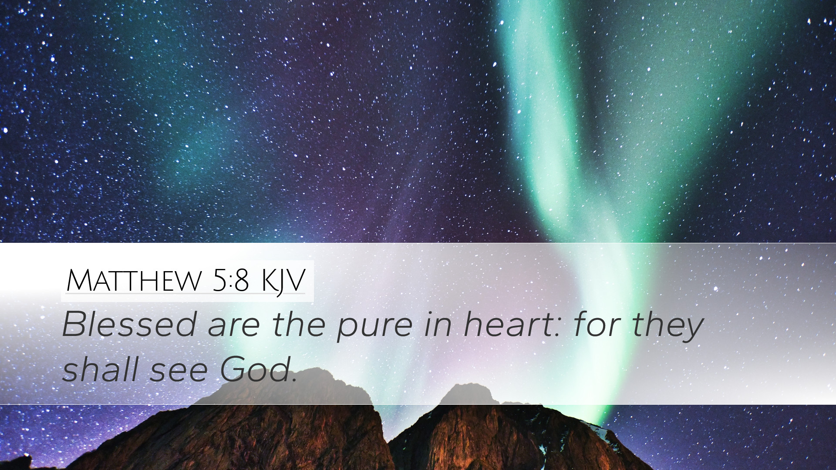

Our Savior’s Lutheran Church
8607 S. Narragansett Ave.
Burbank, Illinois
708-599-4780
www.oursaviorschurch.org

Announcements

Gathering
WELCOME AND ANNOUNCEMENTS
The Peace of Christ be with you
And also with you.

Please take a moment to share a wave, a nod or a sign of peace with those around you. The congregation remains standing.

The Lord is my light and my salvation;
whom shall I fear?
The Lord is the stronghold of my life;
of whom shall I be afraid? (Psalm 27 1 ff)

Confession and Forgiveness
All may make the sign of the cross, the sign that is marked at baptism, as the presiding minister begins.

Blessed be the holy Trinity, ☩ one God, who makes all things new, whose mercy endures forever. Amen.

Trusting in God’s mercy, let us confess our sin.

Silence is kept for reflection.

Holy One, source of our renewal,
We confess that we are wrapped up in sin and cannot free ourselves. We have not practiced your righteousness. Our hearts have turned away from you. For the sake of the world you so love, forgive us, that we may be reconciled to one another for the glory of your holy name. Amen.

Thus says our God: “The former things have come to pass and new things I now declare.” God’s mercy makes us new. We are forgiven in the name of ☩ Christ, our Savior. Amen.

♫Gathering Hymn Here I am to Worship
Light of the world
You stepped down into darkness
Opened my eyes let me see
Beauty that made
This heart adore You
Hope of a life spent with You.

(Chorus)
So here I am to worship
Here I am to bow down
Here I am to say that You're my God
And You're altogether lovely
Altogether worthy
Altogether wonderful to me.
King of all days
Oh so highly exalted
Glorious in heaven above
Humbly You came
To the earth You created
All for love's sake became poor. (chorus)
And I'll never know how much it cost
To see my sin upon that cross
And I'll never know how much it cost
To see my sin upon that cross. (chorus)

The grace of our Lord Jesus Christ, the love of God and the communion of the Holy Spirit be with you all.
c And also with you.

PRAYER OF THE DAY
Holy God, you confound the world’s wisdom in giving your kingdom to the lowly and the pure in heart. Give us such a hunger and thirst for justice, and perseverance in striving for peace, that in our words and deeds the world may see the life of your Son, Jesus Christ, our Savior and Lord. Amen.

The congregation is seated

Word____________________________

A reading from 1 Corinthians

1 Corinthians 1:18-31

Corinth was a port city in the middle of the Roman Empire. Here very rich and very poor lived in proximity. There were persons of business and there were slaves. The truth of Jesus found followers in all of these venues…but others found Christianity ridiculous because the values Jesus taught were counter to empire.

¹⁸For the message about the cross is foolishness to those who are perishing, but to us who are being saved it is the power of God. ¹⁹For it is written, “I will destroy the wisdom of the wise, and the discernment of the discerning I will thwart.” ²⁰Where is the one who is wise? Where is the scribe? Where is the debater of this age? Has not God made foolish the wisdom of the world? ²¹For since, in the wisdom of God, the world did not know God through wisdom, God decided, through the foolishness of our proclamation, to save those who believe. ²²For Jews demand signs and Greeks desire wisdom, ²³but we proclaim Christ crucified, a stumbling block to Jews and foolishness to Gentiles, ²⁴but to those who are the called, both Jews and Greeks, Christ the power of God and the wisdom of God. ²⁵For God’s foolishness is wiser than human wisdom, and God’s weakness is stronger than human strength. ²⁶Consider your own call, brothers and sisters: not many of you were wise by human standards, not many were powerful, not many were of noble birth. ²⁷But God chose what is foolish in the world to shame the wise; God chose what is weak in the world to shame the strong; ²⁸God chose what is low and despised in the world, things that are not, to reduce to nothing things that are, ²⁹so that no one might boast in the presence of God. ³⁰He is the source of your life in Christ Jesus, who became for us wisdom from God, and righteousness and sanctification and redemption, ³¹in order that, as it is written, “Let the one who boasts, boast in the Lord.”

Word of God, word of life.
Thanks be to God.

Please stand

♫GOSPEL ACCLAMATION
(Jesus is) The Light of the World

Jesus is the light of the world,
He is the light of the world,
He is the light of the world, hallelujah!
Jesus is the light of the world, and we will follow him,
Jesus is the light of the world!

The Holy Gospel According to Matthew the 5th Chapter
Matthew 5:1-12
Glory to you, O Lord
Jesus opens the Sermon on the Mount by naming those who are blessed in the reign of God.
When Jesus saw the crowds, he went up the mountain; and after he sat down, his disciples came to him. ²Then he began to speak, and taught them, saying:
³“Blessed are the poor in spirit, for theirs is the kingdom of heaven. ⁴“Blessed are those who mourn, for they will be comforted. ⁵“Blessed are the meek, for they will inherit the earth. ⁶“Blessed are those who hunger and thirst for righteousness, for they will be filled. ⁷“Blessed are the merciful, for they will receive mercy. ⁸“Blessed are the pure in heart, for they will see God. ⁹“Blessed are the peacemakers, for they will be called children of God. ¹⁰“Blessed are those who are persecuted for righteousness’ sake, for theirs is the kingdom of heaven. ¹¹“Blessed are you when people revile you and persecute you and utter all kinds of evil against you falsely on my account. ¹²Rejoice and be glad, for your reward is great in heaven, for in the same way they persecuted the prophets who were before you.
The Gospel of the Lord
c Praise to you, O Christ

the congregation is seated
☺ Children’s Time

Message

♫ Hymn of the Day Christ, Be Our Light

Longing for light, we wait in darkness.
Longing for truth, we turn to you.
Make us your own, your holy people,
light for the world to see.

refrain
Christ, be our light! Shine in our hearts.
Shine through the darkness.
Christ, be our light!
Shine in your church gathered today.

Longing for peace, our world is troubled.
Longing for hope, many despair.
Your word alone has pow’r to save us.
Make us your living voice. (refrain)

Many the gifts, many the people,
Many the hearts that yearn to belong.
Let us be servants to one another,
signs of your kingdom come. (refrain)

The Apostles Creed
Trusting in God, we stand and unite in faith.

I believe in God, the Father almighty, creator of heaven and earth.

I believe in Jesus Christ, God’s only Son, our Lord, who was conceived by the Holy Spirit, born of the virgin Mary, suffered under Pontius Pilate, was crucified, died, and was buried; he descended to the dead. On the third day he rose again; he ascended into heaven, he is seated at the right hand of the Father, and he will come to judge the living and the dead.

I believe in the Holy Spirit, the holy catholic church, the communion of saints, the forgiveness of sins, the resurrection of the body, and the life everlasting. Amen

Prayers of the Church

Called together to follow Jesus, we pray for the church, the world, and all in need.

The congregation is invited to be seated for prayer

Shepherd of the church, cultivate humility in your church. In gatherings of every size, teach us to boast only in the cross. Shape your church to be people of kindness, generosity, and justice. Shepherding God,
receive our prayer.
Faithful child of God, the foundations of the earth bear witness to your faithfulness; the mountains and hills echo with your holiness. Show us the error of our ways when we destroy the earth. Inspire us with reverent awe to honor all you have made. Faithful God,
receive our prayer.
Lord of the world, you make foolish the wisdom of the world. Raise up honorable leaders who seek justice, love mercy, and pursue peace. Frustrate plans that are corrupt, wicked, and self-seeking and show us the reality of intentions. Prosper the work of peacemakers. Wise God,
receive our prayer.
Tender God, bless all whom the world rejects. Accompany those who are regarded as foolish, weak, low, and despised; reveal your power and presence at work where it is least expected. Give your life, strength, and wisdom to all in need (we pause to remember those closes to our hearts and those upon our prayer list) Nurturing God,
receive our prayer.
Empowering God, as with your people Israel, remind Our Savior’s of your saving acts. Remind us how your faithfulness brought us through difficulties and sustained us despite our weaknesses. Establish the cross as the center of our life together. Powerful God,
receive our prayer.
Praise to you for your blessed saints in every time and place who trusted you as you accompanied them even in poverty, persecution, and in every trial. Abide with your people always. Abiding God,
receive our prayer.
We bring to you our needs and hopes, O God, trusting your wisdom and power revealed in Christ crucified.
Amen.

Invitation to Gratitude

Offering

♫Offering Hymn When a Star Is Shining

When a star is shining over eastern hills,
When the air is silent, and the clamor stills,
When the night is waiting, and the old hopes rise,
Then the time has ripened and the heart grows wise.

Refrain
Lead us on, lead us on, to a morning where the promise shines.
Lead us on, lead us on, to a morning where the promise shines.

After the offering has been collected the assembly stands

Offering Prayer
Liberating God,
You break the bonds of injustice and let the oppressed go free. Receive these offerings in thanksgiving for all your works of merciful power, and shape us as people of your justice and freedom. You we magnify and adore, through Jesus our Savior, Amen.

Meal
The Lord be with you.
And also with you.

Lift up your hearts.
We lift them to the Lord.

Let us give thanks to the Lord our God.
It is right to give our thanks and praise.

PREFACE
♫ Holy, Holy, Holy Lord God

Holy, holy, holy Lord God.
God of might and power; Holy is the Lord.
Holy, holy, holy, holy Lord God,
God of might and power; holy is the Lord…
Hosanna in the highest, hosanna here on earth
Blest is he who comes in the name of the Lord.
Hosanna in the highest, hosanna here on earth
Blest is he who comes in the name of the Lord.

Eucharistic Prayer

Lord’s Prayer
Lord, remember us in your kingdom and hear us as we pray:

Our Father, who art in heaven, hallowed be thy name,
thy kingdom come, thy will be done, on earth as it is in heaven.
Give us this day our daily bread;
and forgive us our trespasses, as we forgive those who trespass against us; and lead us not into temptation but deliver us from evil. For thine is the kingdom, and the power, and the glory, forever and ever. Amen

INVITATION TO COMMUNION
Come and taste the joy of God!

♫ O Lamb of God

O Lamb of God, you take away the sin of the world;
Have mercy upon us, have mercy upon us.

O Lamb of God, you take away the sin of the world;
Have mercy upon us, have mercy upon us.

O Lamb of God you take away the sin of the world;
Grant us your peace, grant us your peace.

please be seated
We invite all who trust in Jesus for their life’s journey to share in Holy Communion. Young children are invited to come for a blessing. To receive communion come down the center aisle and fill in around the communion table as room opens up. After receiving communion return via the outside aisle leaving your used cup in the baskets by the first row of pews.
Reception of Holy Communion

the congregation stands
The body and blood of our Lord Jesus strengthen you and keep you in his grace.
Amen

Prayer after Communion
Holy One, we thank you for the healing that springs forth abundantly from this table. Renew our strength to do justice, love kindness, and journey humbly with you. Amen.

Sending
Blessing
The God who faithfully brings forth justice and breaks the oppressor’s rod ☩ bless, strengthen, and uphold you, today and always. Amen.

♫Sending Hymn Carry the Light

In this world of darkness we are given light,
Hope for all the dying.
How will they know? How will they know
That Jesus loves them, and He died to save them?

(chorus)
Carry the Light, carry the Light.
Go and tell the children they are precious in His sight.
Carry the Light, carry the Light.
Go and preach the gospel ‘til there is no more night.
In the name of Jesus Christ, carry the light.

Count them by the millions, blinded slaves to sin.
Inside they are dying.
How will they know? How will they know
That Jesus loves them, and His heart is breaking? (chorus)

Go ye into all the world,
Go ye into all the world, and carry the Light,
Carry the Light.
Go and tell the children they are precious in His sight.
Carry the Light, carry the Light.
Go and preach the gospel ‘til there is no more night
In the name of Jesus Christ, carry the Light, the Light.
Carry the Light.

Dismissal
Go in peace. Follow in the way of Jesus.
Thanks be to God.

Postlude
Here I am to Worship Words and Music by Tim Hughes © - 2000 Thankyou Music (Admin. by EMI Christian Music Publishing) CCLI license #134308 Jesus is the Light of the World By Don Besig and Nancy Price © - 1996, GlorySound All rights reserved. Reprinted under ONE LICENSE #A-704616. Permission to podcast/stream the music in this service obtained from One License with license #A-704616 Christ, Be Our Light Words and Music by Bernadette Farrell © - 1993, Bernadette Farrell, admin. OCP Publications, All rights reserved. Reprinted under ONE LICENSE #A-704616. Permission to podcast/stream the music in this service obtained from One License with license #A-704616 When a Star is Shining Text: Sylvia G. Dunstan Music: Bob Moore Text ©-1995 © GIA Publications, Inc., Music ©-2003 GIA Publications, Inc. All rights reserved. Reprinted under ONE LICENSE #A-704616.Permission to podcast/stream the music in this service obtained from One License with license #A-704616 Holy, Holy, Holy Lord God ELW Setting #7 O Lamb of God ELW Setting #7 Carry the Light Words and Music by Twila Paris © - 1989 Ariose Music/Mountain Spring Music CCLI license #134308 Print and Streaming Evangelical Lutheran Worship © 2006 Evangelical Lutheran Church in America. Published by Augsburg Fortress, Publishers © - Lutheran Book of Worship, 1978, Augsburg Fortress-Publishing Co. The Scripture quotations contained herein are from the New Revised Standard Version Bible, © -1989, by the Division of Christian Education of the National Council of the Churches of Christ in the U.S.A. Used by permission. All rights reserved. Alternate Worship Texts are from Sundays & Seasons, © -2019 Augsburg Fortress. © - Augsburg Fortress license #13825-L All rights reserved. Reprinted under ONE LICENSE #A-704616. Permission to podcast/stream the music in this service Eucharistic prayer: Laughingbird.com

Thank you to today’s Worship Team
Presiding Minister: The Rev. Carole Willer
Assisting Minister – John Schroder
Song Leader – Celebration Band
Audio/visual team – Eli Morales, Gloria Diaz, Pamela Fiore, Jenna Haase, David Henderson, Tony Morales, Greg Nowicki, Veronica Troglia, Diana Mickow
Organ/keyboard: Lori Mackie-Hewelt

